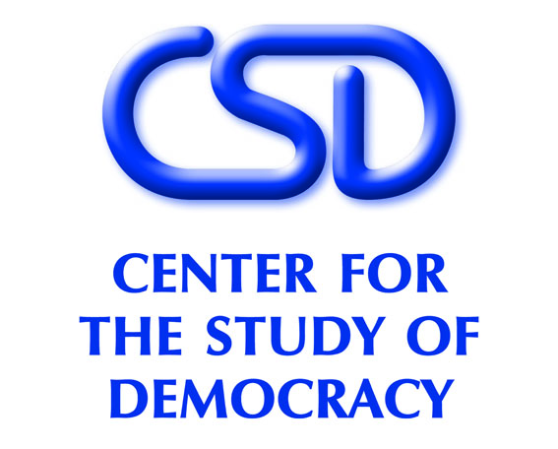

MONITORING OF ANTI-CORRUPTION REFORMS IN BULGARIA
Public Discussion
January 30, 2007, Sheraton Hotel

11.30 Opening
Dr. Ognian Shentov, Chairman, Center for the Study of Democracy

Keynote speakers:
Mr. Roumen Petkov, Minister of Interior and Chairman of the Commission for the Prevention and Counteraction of Corruption, Council of Ministers
Ms. Gudrun Steinacker, Deputy Chief of Mission, Embassy of the Federal Republic of Germany
Mr. Alexander Karagiannis, Deputy Chief of Mission, Embassy of the United States

12.00 Indicators for assessment of the implementation of the anti-corruption strategy of the government of Bulgaria
Mr. Alexander Stoyanov, Director, Vitosha Research

A view from the private sector: measuring business corruption
Mr. Ruslan Stefanov, Economic Program Coordinator, Center for the Study of Democracy

Discussion
13.00 Closing remarks

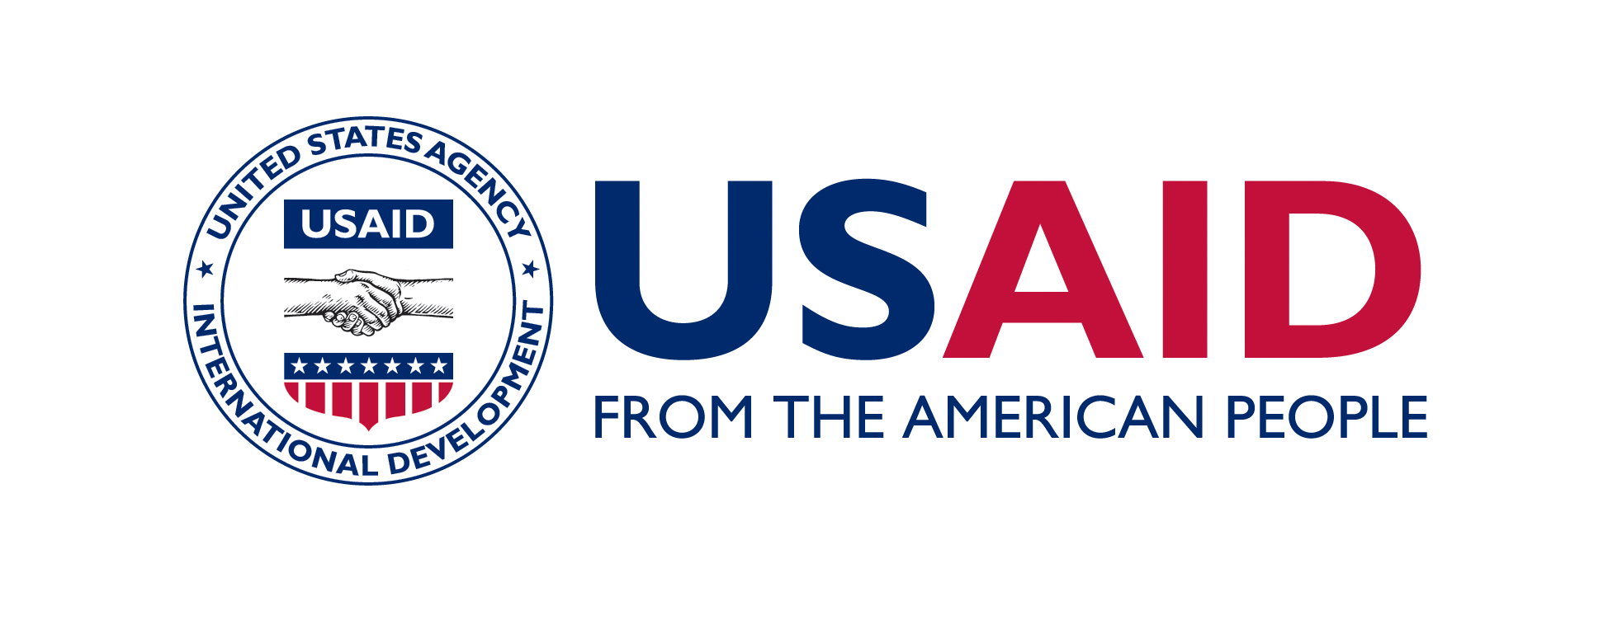 This event is made possible by the generous support of the American people through the United States Agency for International Development (USAID). The contents are the responsibility of the CSD and do not necessarily reflect the views of USAID or the United States Government.

