 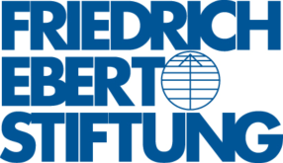

The Center for the Study of Democracy

and

Friedrich Ebert Foundation

*have the pleasure to invite you to*

*a public discussion on*

**THE HIDDEN ECONOMY IN BULGARIA: 2012 – 2013**

20 November 2013

Bulgarian Telegraph Agency

49, Tzarigradsko Shouse

**10:30** *Opening*

**Ruslan Stefanov,** Director, Economic Programme, Center for the Study of Democracy

**Regine Schubert**, Director, Friedrich Ebert Foundation, Office Bulgaria

**10:40** *The Hidden Economy in Bulgaria (2012-2013)*

**Martin Tsanov,** Analyst, Economic Programme, Center for the Study of Democracy

**Todor Galev,** Senior Analyst, Economic Programme, Center for the Study of Democracy

**11:00** *Discussion*

*Moderator:* **Pentcho Houbtchev,** Programme Coordinator, Friedrich Ebert Foundation, Office Bulgaria